# Algorithm for file updates in Python

## Project description

In this project I created an algorithm in Python to check whether the allow list contains any IP addresses on the remove list. If there are IP addresses that need to be removed, the algorithm removes them.

## Open the file that contains the allow list

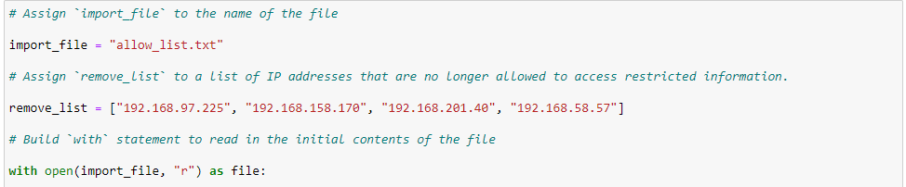

In this step I imported the file “allow_list.txt” and stored it in the variable file.

The second argument, “r”, was passed into the open() function because I wanted to read the file contents.

## Read the file contents

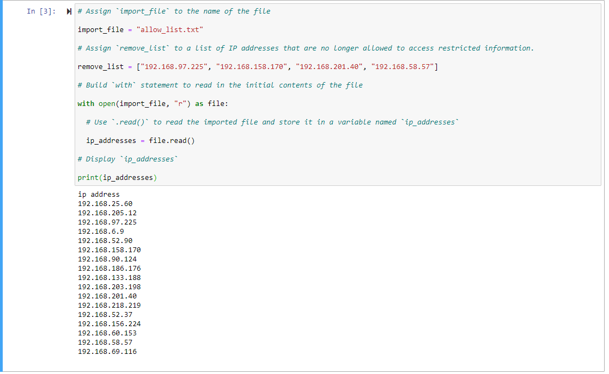

I first stored the contents of the file variable in the ip_addresses variable, and I used the print() function to read the file contents, which displayed as a string.

## 

## Convert the string into a list

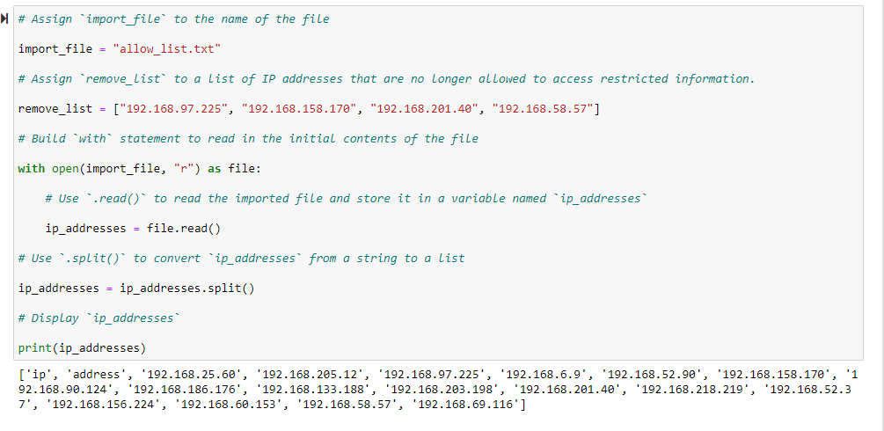

By using the split() method, I converted the string into a list.

## Iterate through the remove list

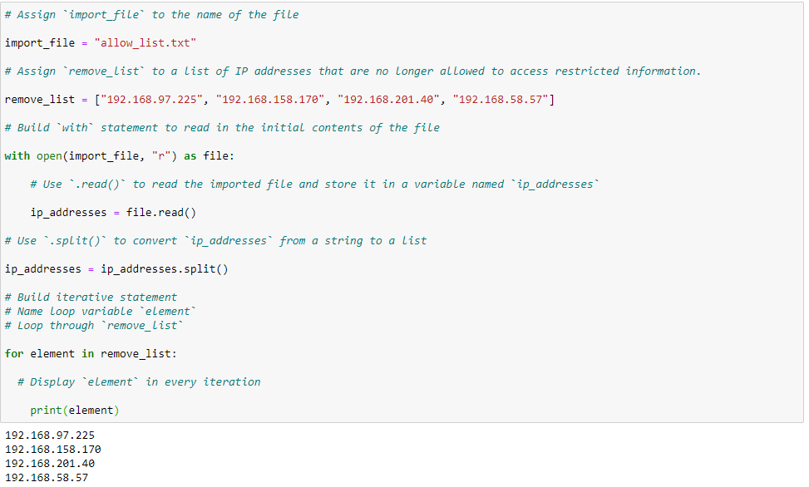

In this step, I iterated through the remove_list and displayed each element of the list. The loop variable is named element, and each value was displayed.

## Remove IP addresses that are on the remove list

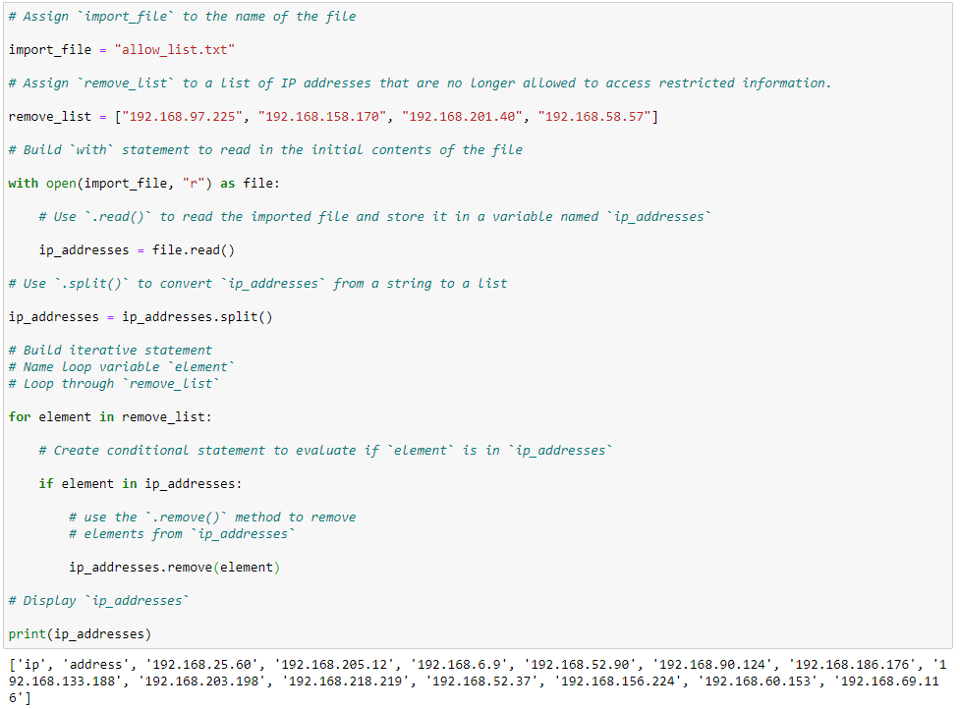

In this step, I removed the IP addresses on the remove list from the list of IP addresses. I first iterated through the remove_list, and using a conditional if statement I removed the IP addresses from the ip_addresses list if they were present in the remove_list.

## Update the file with the revised list of IP addresses

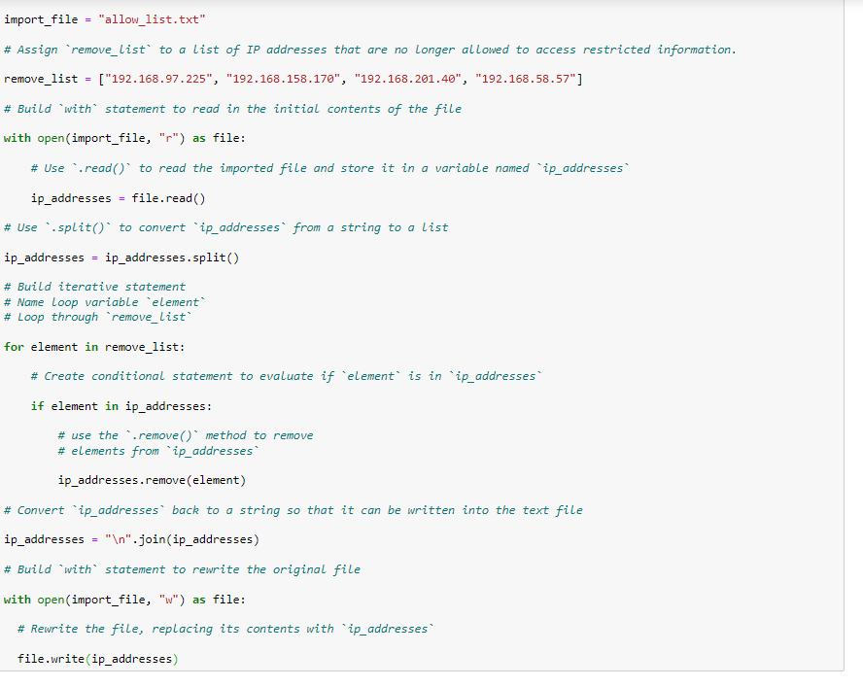

In this step, I updated the file with a revised list of IP addresses. Using the update list that was output from the previous steps, I passed “w” as the second argument in the open() function, and rewrote the file, replacing its contents with “ip_addresses”.

## Summary

This project demonstrates my ability to create functions, iterate through lists, edit lists, import files, and edit files in Python.